EXPERIMENT-4
Aim
To develop a cloud-based Car Booking Reservation Application using Zoho Creator that allows users to book cars online and manage reservations through the cloud.
Software Used
- Zoho Creator
- Web Browser (Chrome/Edge)
- Zoho Cloud Platform
Algorithm
- Open Zoho Creator.
- Create a new application named Car Booking Reservation System.
- Add the required fields.
- Enter customer and booking details.
- Click Submit.
- Store booking details in the cloud database.
- Display booking confirmation.
Output:
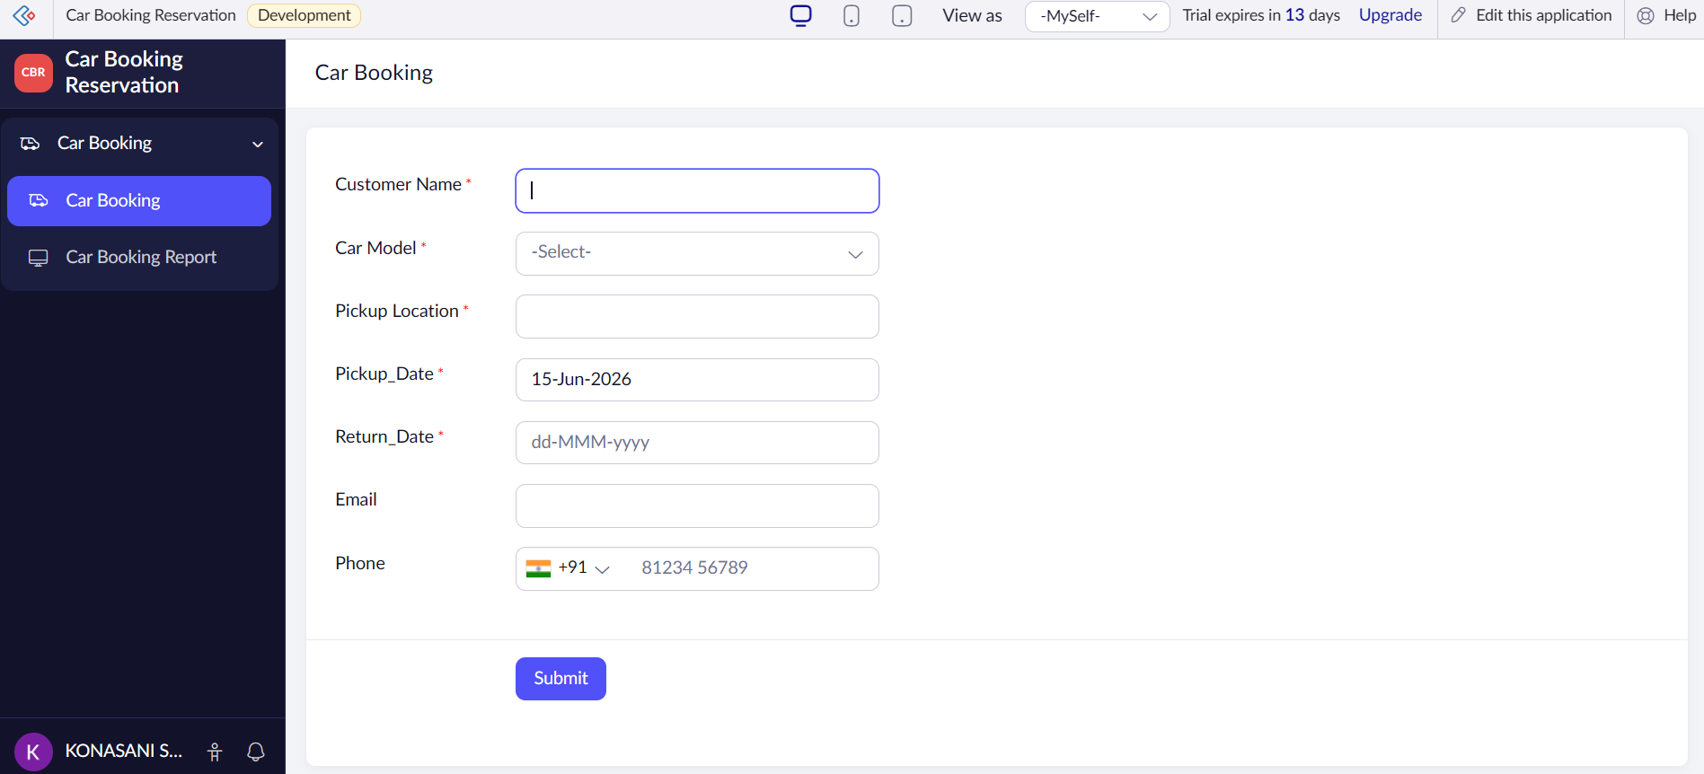
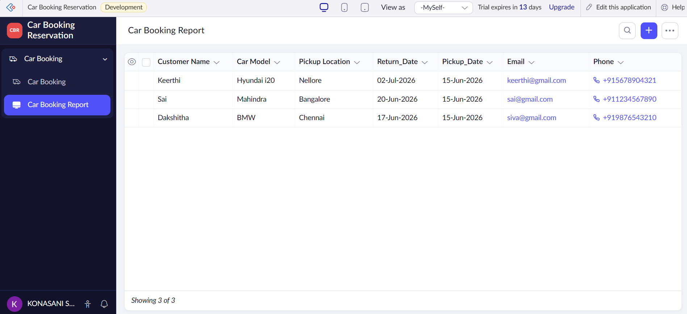

Result
The Car Booking Reservation Application was successfully developed using Zoho Creator SaaS. The system enables users to reserve cars online, store booking details in the cloud, and receive booking confirmations.

